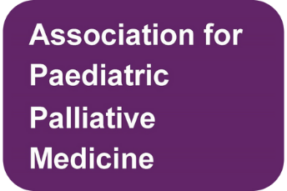
Abstract Submission for Poster
APPM Conference – 21/22 November 2024

Last submission date: 31 July 2024
Notification of acceptance: week commencing 1 September 2024
Please send to admin@appm.org.uk and you will receive an acknowledgement on receipt.

Name of presenter(s)
Professional role / designation
Name of supervisor (if applicable)
Trust, university, hospice or affiliation
Poster Title
Contact details
Abstract (maximum 300 words within this section) outlining the focus and key messages of your project.

